Bethany United Methodist Church
Guiding Principles
Guiding Principles Index

ARTICLE 1: MISSION PRINCIPLES (MP)
MP 1.0 COMPREHENSIVE MISSION STATEMENT…………………. | 4
MP 2.0 COMPREHENSIVE VISION STATEMENT…………………… | 4
MP 3.0 COMPREHENSIVE VALUES OF THE CHURCH……………. | 5
ARTICLE 2: BOUNDARY PRINCIPLES (BP)
BP 1.0 ETHICAL COMPREHENSIVE STATEMENT………………… | 7
BP 2.0 BIBLICAL INTEGRITY STATEMENT…………………………. | 8
BP 3.0 FINANCIAL MANAGEMENT STATEMENT………………….. | 8
BP 4.0 SAFE SANCTUARIES…………………………………………… | 9
BP 5.0 PASTOR-PARISH RELATIONS STATEMENT……………….. | 10
BP 6.0 PASTOR-STAFF RELATIONS STATEMENT………………… | 10
BP 7.0 PASTOR-CHURCH COUNCIL RELATIONS STATEMENT… | 10
BP 8.0 PASTOR SUCCESSION………………………………………… | 12
ARTICLE 3: ACCOUNTABILITY PRINCIPLES (AP)
AP 1.0 COMPREHENSIVE ACCOUNTABILITY STATEMENT……… | 13
AP 2.0 CHURCH COUNCIL CODE OF CONDUCT………………….. | 13
AP 3.0 THE PROCESS OF THE CHURCH COUNCIL………………. | 13
AP 4.0 RESPONSIBILITY OF THE CHAIRPERSON………………… | 14
AP 5.0 RESPONSIBILITY OF THE RECORDING SECRETARY…… | 14
AP 6.0 RESPONSIBILITY OF THE CHURCH COUNCIL……………. | 15
AP 7.0 RESPONSIBILITY OF THE PASTOR ………………………… | 15
AP 8.0 MONITORING THE PERFORMANCE OF THE PASTOR…... | 16
AP 9.0 ANNUAL GOALS OF THE PASTOR AND CHURCH  COUNCIL………………………………………………………….. | 16
ARTICLE 4: ORGANIZATIONAL PRINCIPLES (OP)
OP 1.0 COMPREHENSIVE OPERATIONAL STATEMENT…………. | 17
OP 2.0 THE HEAD OF THE CHURCH…………………………………. | 17
OP 3.0 THE ROLE OF THE CHURCH COUNCIL…………………….. | 18
OP 4.0 THE ROLE OF THE PASTOR………………………………….. | 18
OP 5.0 ELIGIBILITY TO BE A MEMBER OF THE CHURCH  COUNCIL…………………………………………………………. | 18
OP 6.0 MAKEUP OF THE CHURCH COUNCIL……………………… | 19
OP 7.0 MAKEUP OF NOMINATIONS AND LEADERSHIP  DEVELOPMENT COMMITTEE………………………………… | 21
OP 8.0 THE ROLE OF STAFF MEMBERS/MINISTRY TEAM  CHAIRPERSONS………………………………………………... | 22
OP 9.0 THE ROLE OF THE MINISTRY TEAMS……………………… | 23
APPENDIX A
BETHANY UNITED METHODIST CHURCH COUNCIL COVENANT | 24
APPENDIX B
MINISTRY TEAM ANNUAL EFFECTIVENESS REPORT……………. | 25
APPENDIX C
TRAINING HANDBOOK………………………………………………….. | 27

ARTICLE 1: MISSION PRINCIPLES (MP)
Defining what difference this church will make for whom and to what extent

MP 1.0 COMPREHENSIVE MISSION STATEMENT
Bethany United Methodist Church is to make disciples of Jesus Christ for the transformation of the world.
MP 1.1 This is the mission statement of the United Methodist Church and one we readily adopt as a part of that denomination.
MP 2.0 COMPREHENSIVE VISION STATEMENT
We are a beacon for God—helping people to see, accept and grow in the light of Jesus Christ.
MP 2.1 “Helping people to see” that God is at work in their lives even before they may know it. “Helping people to accept” that Jesus Christ is their Lord and Savior. “Helping people to grow” in their relationship with God and with one another. ​​​​​​​​Together we reflect God's light in the world we serve.
MP 2.2 The symbol of the lighthouse has become our trademark to signify that we are beacons for God. God gives us what we need to shine forth God’s light into the world.
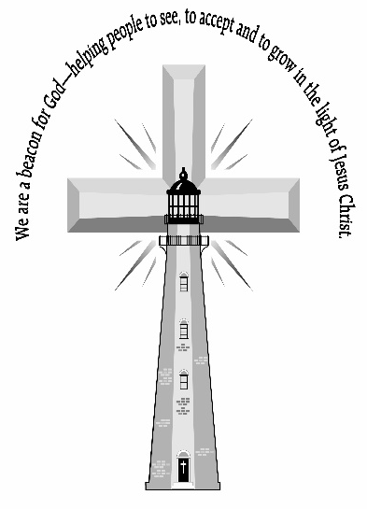
MP 2.3 Prevenient, justifying, and sanctifying grace are all represented in this vision statement. John Wesley, the founder of the Methodist movement, taught that:
MP 2.3.1 Prevenient (or preventing) grace is the grace of God we experience before we realize we are even experiencing it. That is what we mean by “helping people to see.”
MP 2.3.2 Justifying grace is grace that brings us into alignment with God’s will. We become justified in God’s sight, not because of any merits of our own, but through what Christ did for us on the cross. This is what we mean by “helping people to accept.”
MP 2.3.3 Sanctifying grace is the grace we experience once we realize God is working in our lives and after we have accepted Jesus Christ as our Lord and Savior. Sanctification is growing more holy, growing more into Christ’s likeness. This involves doing good works, not because that is what will get us into heaven, but because we desire to do them for the God we love. That is what we mean by “helping others to grow.”
MP 3.0 COMPREHENSIVE VALUES OF THE CHURCH
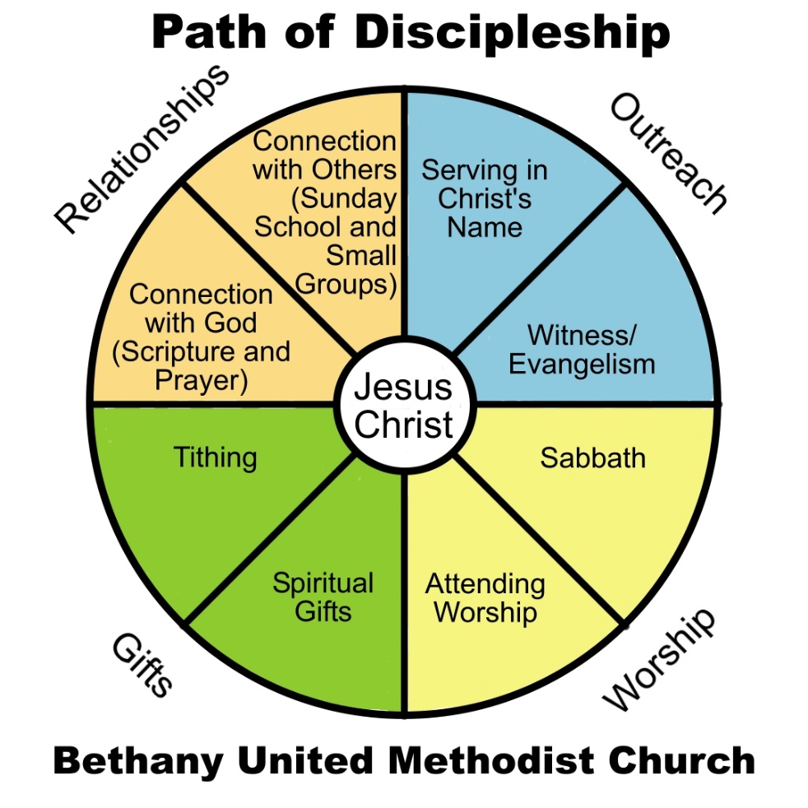
MP 3.1 Our church strives to have an intentional plan to make disciples of Jesus Christ. This plan we refer to as our “Path of Discipleship.” This framework is:
MP 3.1.1 To help us fulfill the commission of Christ to “go, make disciples of all nations” (Matthew 28:19).
MP 3.1.2 To guide our strategies that will continually be tweaked to fit the times, the culture, and the context, among other factors.
The need to follow Christ never changes but the way we strategize to lead others to Christ will always be open to change.
MP 3.2 The acronym GROW is a convenient way to remember the four categories of discipleship, which we refer to as our values: Gifts, Relationships, Outreach, and Worship.
MP 3.2.1 Eight disciplines of the Path of Discipleship. Each of these values of GROW have two sub-categories, eight in total, which comprise the basic disciplines of a growing Christian disciple:
a. Spiritual gifts
b. Tithing
c. Connection with God through prayer and Scripture reading
d. Connection with others through Sunday School and small groups
e. Serving in Christ’s name
f. Witness/evangelism
g. Observing the Sabbath
h. Attending public worship
MP 3.2.2 Work in progress. To GROW as Christian disciples we should be working on all eight of these disciplines, yet for many it would be too daunting. It would be like asking someone to run a marathon when they have not been preparing to do more than walk. The average person might start out well, but then give up before long and not bother to ever try again. Each of these disciplines take time, energy, and lots of practice. We are all a work in progress.
MP 3.2.3 One step at a time. We need to celebrate when anyone even makes a few steps closer in their walk with Christ. Imagine the outer edge of the circle to be where you are right now in your relationship with Christ. Disciples strive to take intentional steps to go from where they are now to draw closer to Christ as center of their lives, becoming more and more what Christ intends them to become.

ARTICLE 2: BOUNDARY PRINCIPLES (BP)
Defining the limits of acceptable means that the Pastor is authorized to use in achieving the Mission
BP 1.0 ETHICAL COMPREHENSIVE STATEMENT
The Pastor shall not cause, condone or endorse any practice, activity, decision, or organizational circumstance that is unlawful, imprudent, unethical, or unbiblical (see Biblical Integrity Statement BP 2.0).
The Pastor shall not violate The Book of Discipline of the United Methodist Church.
BP 1.1 PASTORAL COUNSELING AND CONFIDENTIALITY. Communications between the Pastor and a church member (or non-member) must be confidential if made privately for the purpose of seeking spiritual counsel, coaching, or advice.
BP 1.1.1 The Pastor shall not breach confidentiality except when safety is an issue.
BP 1.1.2 The Pastor shall not practice counseling beyond his/her expertise and training, but may choose to refer people to professionals with greater expertise or relevant specialties, when necessary.
BP 1.2 PROFESSIONAL INTEGRITY. The Pastor must recognize the power that is inherent in the leadership role, which can be used for good or could harm others.
BP 1.2.1 The Pastor must be committed to maintaining the pastor’s and the church’s honor, integrity, and credibility.
BP 1.2.2 The Pastor must be committed to justice and shall not abuse the position by taking advantage of it for the purposes of personal, institutional, political, or financial gain.
BP 1.2.3 The Pastor shall always work toward and promote the biblical unity of the congregation.
BP 1.2.4 The Pastor must seek to develop leadership in others.
BP 1.2.5 The Pastor shall not be defensive over another person excelling in an area of ministry in the church, but must instead encourage them in it.
BP 1.2.6 The Pastor shall not micromanage ministry teams.
BP 1.3 BEHAVIORAL ETHICS. The Pastor shall not become overcommitted to non-Pastoral activities or obligations to the point they impede church duties and responsibilities.
BP 1.4 PREACHING AND TEACHING. The Pastor must give adequate time to preparation and prayer, so that her/his presentations are biblically true and easily understood.
BP 1.5 The Pastor shall not plagiarize the ideas of others, but must acknowledge sources for sermons and written material.
BP 1.6 The Pastor shall not abandon the Wesleyan practice of the primacy of Scripture, as informed by Reason, Tradition, and Experience. The Pastor shall strive to connect this practice to the issues of today in the language and forms of the particular worshipping community.
BP 2.0 BIBLICAL INTEGRITY STATEMENT
By upholding the highest standards of Biblical teaching and morality the Pastor shall use and promote conditions, procedures, and decisions that are safe, dignified, personal, and, when appropriate, provide protections for confidentiality and privacy.
BP 3.0 FINANCIAL MANAGEMENT STATEMENT
The Pastor, with the assistance of the staff, and members of the Church Council, shall prepare and approve an annual budget.
BP 3.0.1 Each ministry team must submit a funding request, even if the request is for zero dollars, as part of the Ministry Team Annual Effectiveness Report (see Appendix B). The request will need to be presented so that it can be approved as part of the annual budget.
BP 3.0.2 The annual budget may include a contingency fund
a. As seed money for those ministry teams that have unexpected expenses
b. For new ministry teams that may start up in that budget year
BP 3.0.3 The Church Council is responsible for managing the budget.
BP 3.0.4 Once the budget is approved, those responsible (i.e., staff and team leaders) for the various ministry areas have the authority to spend their budget in alignment with the objectives for their ministry area approved by the Church Council.
BP 3.0.5 No further approval is needed to access the budget in their area of responsibility, with the exception of confirming with the Church Treasurer monies are available for any purchases over $500.
BP 3.1 EXPENSES OVER BUDGET. Anything that is an addition to or an increase over the budget will need approval of the Church Council.

BP 3.2 INAPPROPRIATE EXPENDITURES. All ministry areas of the church are expected to be in alignment with the church’s mission, vision, and values.
BP 3.2.1 The purpose, function, and effectiveness of each ministry area shall be reviewed in accordance with Appendix B (Ministry Team Annual Effectiveness Report)and evaluated by the Church Council.
BP 3.2.2 If the ministry area is deemed out of compliance with the church’s mission, vision, and values said ministry area will either need to be brought into compliance or be terminated.
BP 3.3 APPROPRIATE EXPENDITURES. Once the budget is approved, those responsible (i.e., staff, ministry team chairperson, or ministry team leader) for the various ministry areas have the authority to spend their budget to align with the objectives for their ministry area. No further approval is needed to access the budget in their area of responsibility under $500.
BP 3.3.1 Availability of funds for purchases over $500 shall be checked with the Church Treasurer prior to expenditure. The Church Treasurer does not approve or deny purchases but rather confirms large purchases will not create cash flow issues.
BP 3.4 Any member of the Building Maintenance Team (a team formed by the Trustees Lead) has the authority to purchase supplies for building maintenance and improvement up to $500 without approval. The Trustees Lead can authorize purchases for building maintenance and improvement up to $1,000. Any purchases over these amounts would need to be approved by the Church Council.
BP 3.4.1 Any expenditure over $5,000 will require three bids.
BP 4.0 SAFE SANCTUARIES
BP 4.1 SAFE SANCTUARIES POLICY. The Pastor, in consultation with the Church Council, shall ensure that all staff and volunteers who work with children under the age of 18 and with vulnerable adults adhere to the “Safe Sanctuary Policy of Bethany United Methodist Church.” This includes that the backgrounds of all staff and volunteers are properly checked.
BP 4.2.1 The Pastor, in consultation with the Church Council, shall ensure that the Safe Sanctuary Policy is kept up to date.
BP 4.2.2 The Pastor shall maintain personal and professional practices that adhere to the Susquehanna Conference’s Safe Sanctuary policy [http://susumc.org/index.php/about-us/safe-sanctuaries]
BP 5.0 PASTOR-PARISH RELATIONS STATEMENT
BP 5.1 GRIEVANCE AGAINST THE PASTOR. If any person, staff or laity, has a grievance against the Pastor:
BP 5.1.1 The person with the grievance should first try to reconcile the issue directly with the Pastor.
BP 5.1.2 The Pastor shall not prevent that person from bringing the grievance to the attention of the Church Council Chairperson.
BP 5.1.3 The Church Council Chairperson and the person with the grievance should meet with the Pastor to resolve the issue.
BP 5.1.4 If the issue is still not resolved to satisfaction, then the grievance shall be brought before the entire Church Council for review.
BP 5.1.5 The Church Council shall implement a just resolution for the staff or layperson and the Pastor.
BP 5.1.6 The Church Council shall consult with the Lewisburg District Superintendent for guidance through this process.
BP 6.0 PASTOR-STAFF RELATIONS STATEMENT
The Pastor is directly responsible for the staff. The Pastor mentors and provides guidance for the staff to ensure fruitful ministry. The Pastor is primarily responsible and held accountable for the staff’s overall job performance.
BP 6.1 HIRING AND TERMINATION OF STAFF. The Pastor shall hire and terminate staff consistent with goals and budgets approved by the Church Council. The Pastor shall execute all major staff decisions in collaboration with the Church Council.
BP 6.2 JOB DESCRIPTIONS. The Pastor, in consultation with the Church Council, shall develop and maintain appropriate job descriptions, as well as conduct an annual review for all staff. One or more members of the Church Council shall be a part of these annual reviews.
BP 6.3 MAJOR STAFF ISSUE. Any major staff issue shall be brought to the attention of the Church Council by the Pastor before any punitive action is taken.
BP 7.0 PASTOR-CHURCH COUNCIL RELATIONS STATEMENT
The Pastor is held accountable by the Church Council to ensure that these Boundary Principles are upheld and implemented. These Boundary Principles are subject to review and addition/correction by the Church Council on at least an annual basis.

BP 7.1 THE CHURCH COUNCIL AS A DISCIPLESHIP ATMOSPHERE. The Pastor shall create a discipleship atmosphere at the Church Council level:
BP 7.1.1 The Pastor shall ensure that every Church Council member, including the Pastor, is growing in their relationship with Jesus Christ.
BP 7.1.2 This includes, but is not limited to, ensuring that each Church Council meeting is started with prayer, Scripture, and a Bible-based devotion.
a. Each Church Council member should take a turn to lead in prayer, Scripture and devotions on a rotating basis.
BP 7.2 CHURCH COUNCIL MEETINGS. The Pastor and Chairperson shall ensure Church Council meetings support and enhance our mission and vision statements.
BP 7.2.1 The Council shall not focus on micromanagement, outside of conducting an investigation.
BP 7.2.2 The Council shall think strategically about the future of Bethany United Methodist Church:
a. For the immediate one year plan
b. For a three to five year timeline (see AP 9.2)
BP 7.2.3 All normal Church Council meetings shall be open meetings for congregational members to observe if they wish.
a. It is preferred that observers notify the Pastor or Chairperson in advance of their intention to address the Council.
b. The Pastor or Chairperson shall communicate this to the Council prior to the meeting.
c. Church Council meetings shall only be closed when the Church Council must go into Executive Session (this includes, but is not limited to, conversations about staffing issues, staff salaries, and the annual review of the Pastor).
BP 7.3 COMMUNICATION, SUPPORT AND WORKING RELATIONSHIP BETWEEN THE CHURCH COUNCIL AND THE PASTOR.
BP 7.3.1 Both the Pastor and Church Council shall communicate with each other in a manner that:
a. Promotes teamwork and respect
b. Holds each other accountable to responsibilities and roles
BP 7.4 CHURCH COUNCIL TRAINING. The Pastor and Chairperson shall ensure the Church Council members are appropriately trained, with periodic training reviews of these guidelines.
BP 7.4.1 The Nominations and Leadership Development Committee is responsible for the initial training in accordance with Appendix C [to be developed].
BP 8.0 PASTOR SUCCESSION
The Pastor shall support the current United Methodist Book of Discipline’s denominational rules governing the succession of Pastors and make sure the Church Council is familiar with the process and any issues and processes the Pastor may be involved in at the time of succession.

ARTICLE 3: ACCOUNTABILITY PRINCIPLES (AP)
Defining for the Chairperson the standards to uphold for enforcing the integrity and fulfillment of the Church Council’s process.
AP 1.0 COMPREHENSIVE ACCOUNTABILITY STATEMENT
The responsibility of the Church Council before God, and on behalf of the unchurched in our community and members of the Bethany United Methodist Church, is to ensure that Bethany UMC, through the leadership of its Pastor:
AP 1.1 Achieves the fulfillment of the Mission Principles
AP 1.2 Avoids violation of the Boundary Principles
AP 2.0 CHURCH COUNCIL CODE OF CONDUCT
On an annual basis the members of the Church Council shall sign the Bethany United Methodist Church Council Covenant (see Appendix A)
AP 2.1 This is a means to govern each individual’s spiritual and leadership development
AP 2.2 This helps to ensure that members of the Church Council strive to live a life of holiness by growing in their walk with Jesus Christ through, at least, their Gifts, Relationships, Outreach and Worship.
AP 3.0 THE PROCESS OF THE CHURCH COUNCIL
The Church Council shall govern under the following guidelines:
AP 3.1 Maintaining an outward vision rather than internal preoccupation
AP 3.2 Encouragement of diversity of viewpoints
AP 3.3 Strategic leadership more than administrative detail
AP 3.4 Creating and maintaining clear distinctions between the roles of the Church Council members and the staff/ministry team chairpersons
AP 3.5 Collective decision making rather than decisions made by individuals
AP 3.6 Emphasis on the future
AP 3.7 Being proactive rather than reactive

AP 4.0 RESPONSIBILITY OF THE CHAIRPERSON
AP 4.1 The Chairperson shall prepare and coordinate the meeting agenda with the Pastor.
AP 4.1.1 Meeting agenda shall be distributed to all Church Council members at least one week in advance of Church Council meetings. This should be coordinated with step AP 4.2
AP 4.1.2 The distribution of the meeting agenda is intended to provide preparation time for all Church Council members to be prepared to discuss, or answer questions, concerning agenda items.
AP 4.2 The Chairperson shall communicate meeting times and locations at least one week in advance of Church Council meetings.
AP 4.3 The Chairperson ensures the integrity and fulfillment of the Church Council’s process, including the monitoring of the Pastor’s performance.
AP 4.4 The Chairperson is authorized to use a reasonable interpretation of the Accountability Principles as she or he acts to ensure the integrity of the Church Council’s process.
AP 5.0 RESPONSIBILITY OF THE RECORDING SECRETARY
On an annual basis the Church Council shall appoint a Recording Secretary who shall:
AP 5.1 Maintain accurate minutes of meetings for future reference and historical accuracy. The minutes shall include an attendance roster.
AP 5.2 Ensure that Church Council materials are documented and stored in an appropriate manner.
AP 5.2.1 It is recommended that an audible recording be made of each meeting, and that it is announced to all present that the meeting is being recorded.
a. Audible recordings will be stored in an appropriate manner.
AP 5.2.2 A hard copy printout of meeting minutes will also be stored in an appropriate manner.
AP 5.3 Ensure that copies of the Church Council minutes are available to any member of Bethany UMC.
AP 5.3.1 Church Council minutes shared with any member of the church shall not include Executive Session (SPRC) issues.

AP 6.0 RESPONSIBILITY OF THE CHURCH COUNCIL
AP 6.1 The Church Council has the responsibility of the governance of the church. There are three types of work for the governing board of the church:
AP 6.1.1 Fiduciary = tending to the stewardship of tangible assets
AP 6.1.2 Strategic = working to set the congregation’s priorities and seeing that resources are aligned with those priorities
AP 6.1.3 Generative = problem framing and understanding about the shifting environment of the congregation and community
AP 6.2 The Church Council shall be responsible for:
AP 6.2.1 Reviewing and amending the Guiding Principles, setting boundaries, budget, policy, goals, and oversight.
AP 6.2.2 Working in partnership with programs and ministries to ensure they align with the mission, vision, and values of the church.
AP 6.2.3 Working with the District Superintendent to hold the Pastor accountable.
AP 7.0 RESPONSIBILITY OF THE PASTOR
AP 7.1 The Pastor has the responsibility, authority, and accountability to:
AP 7.1.1 Serve as the primary visionary leader of the church at every level: congregation, staff, and Church Council.
AP 7.2 If a question arises with regard to the Guiding Principles of the church, the Pastor shall:
AP 7.2.1 First be in advisement to the Church Council
AP 7.2.2 If necessary, be in advisement to the Cabinet of the Susquehanna Conference
AP 7.3 The Pastor shall be the primary spiritual shepherd, leader, and preacher for the congregation.
AP 7.3.1 The Pastor shall plan and conduct the various worship services, including sermon preparation and working with others who lead and participate in worship.
AP 7.3.2 The Pastor shall guide all church leaders by articulating the vision of the church and focusing the work of the whole congregation toward the accomplishment of that vision.
AP 7.3.3 The Pastor shall have oversight of all committees and teams in the implementing of programs that help further the mission, vision, and values of Bethany United Methodist Church.
AP 7.4 The Pastor shall ensure that systems and ministries are in place to effectively move people into a deeper relationship with Jesus Christ through applying the eight disciplines of the Path of Discipleship.
AP 7.4.1 The Pastor shall ensure all ministries are organized in accordance with the mission of the church.
AP 7.4.2 The Pastor shall manage the effectiveness of all staff and ministry team chairpersons, who in turn empower and train the laity to help accomplish the mission.
AP 7.5 The Pastor shall be held accountable for the ethical and biblical boundaries as outlined in the Boundary Principles by the Church Council.
AP 8.0 MONITORING THE PERFORMANCE OF THE PASTOR
The Church Council shall review at least annually, in cooperation with the evaluation forms required by the District Superintendent, the achievement and conduct of the Pastor.
AP 9.0 ANNUAL GOALS OF THE PASTOR AND CHURCH COUNCIL
The Pastor and the Church Council shall:
AP 9.1 Review the previous year’s accomplishments as they relate to goals and budget.
AP 9.2 Set church-wide immediate goals for the coming year and plan future goals for three to five years to come.
AP 9.2.1 These goals should be SMART (Specific, Measurable, Achievable, Relevant, Time-Based)
AP 9.2.2 These goals should answer the questions: Who? When? Where? How? Did it work?

ARTICLE 4: ORGANIZATIONAL PRINCIPLES (OP)
Defining how the church will be organized for optimal operational efficiency and effectiveness.
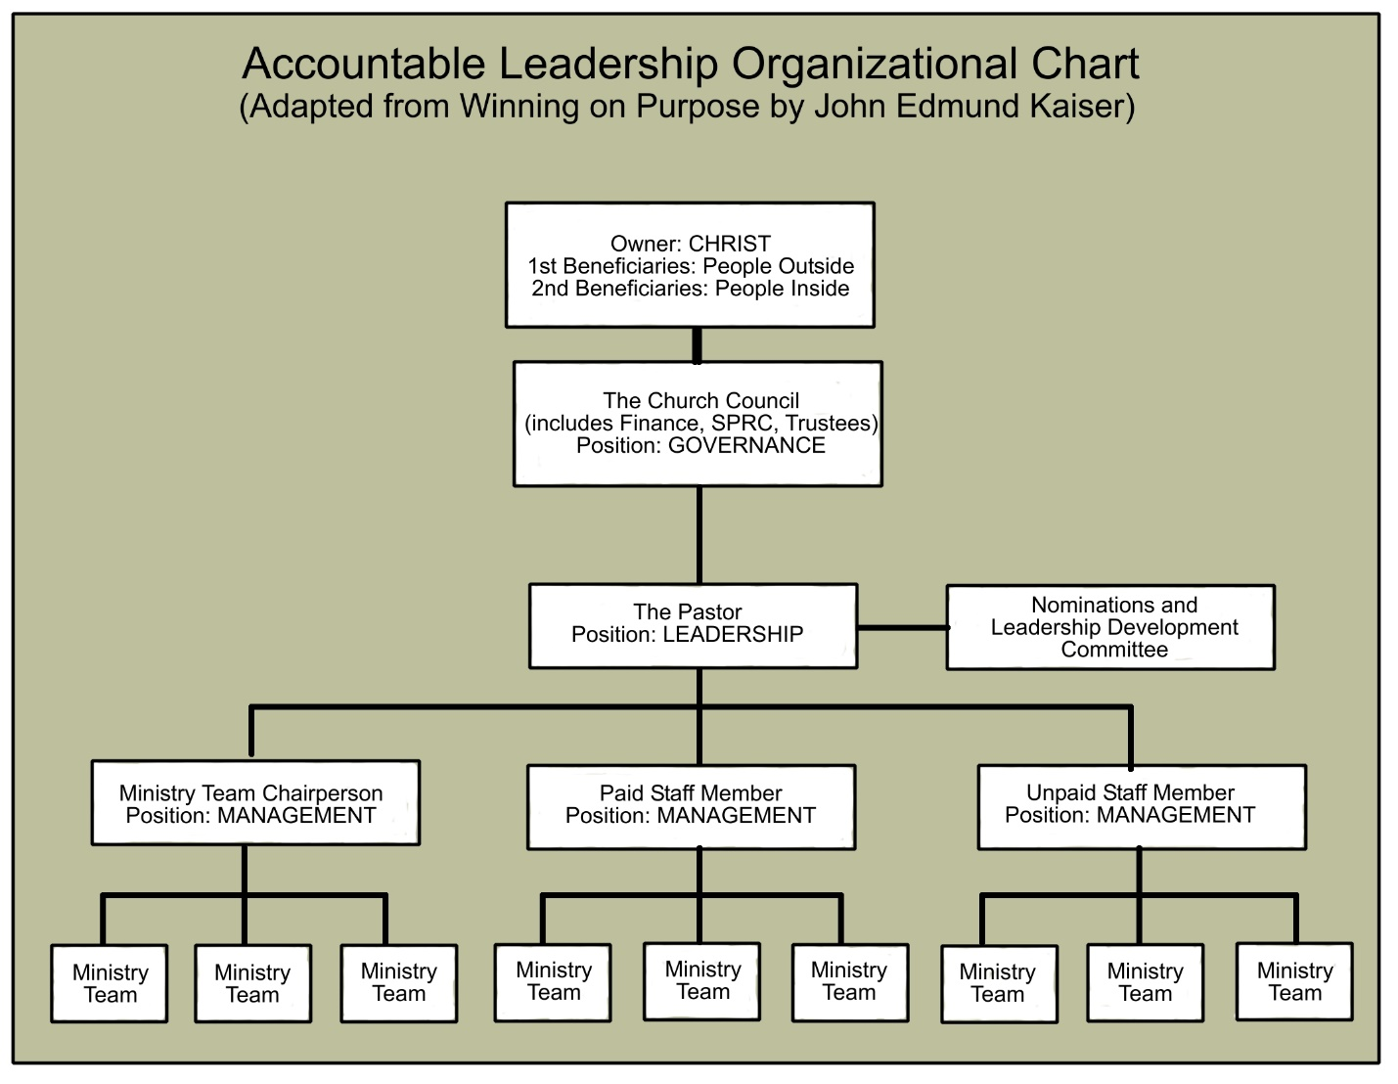
OP 1.0 COMPREHENSIVE OPERATIONAL STATEMENT
The church shall be organized in such a manner as to promote efficient and effective decision-making with appropriate boundaries for checks and balances and appropriate levels of accountability.
OP 2.0 THE HEAD OF THE CHURCH
Jesus Christ shall always be the Head of the Church and the Church shall always be the Body of Christ. All church leaders are to keep their eyes focused on Jesus Christ.

OP 3.0 THE ROLE OF THE CHURCH COUNCIL
The Church Council shall function in the role of the Board of Directors of the church as follows:
OP 3.1 The Church Council encompasses the roles of the Trustees, Finance Committee, and Staff-Pastor Parish Relations Committee.
OP 3.2 Except as shall be specifically delegated, all legal authority shall vest in the Church Council and no person may legally bind the church to any obligation without the prior approval of the Church Council.
OP 3.3 The Church Council shall act on behalf of the church in accordance with the Book of Discipline and in compliance with these Guiding Principles.
OP 3.3.1 In the event of a conflict between these Guiding Principles and the Book of Discipline, the Book of Discipline shall take precedence.
OP 3.4 CHAIRPERSON’S CONTRACTURAL AUTHORITY. The Chairperson of the Church Council shall have the authority to legally bind the church on contracts and obligations upon approval of the Church Council, subject to the Book of Discipline.
OP 4.0 THE ROLE OF THE PASTOR
The Pastor shall function in the role of president or chief executive officer of the church.
OP 4.1 The Pastor shall be subject to the provisions of these Guiding Principles and the Book of Discipline.
OP 5.0 ELIGIBILITY TO BE A MEMBER OF THE CHURCH COUNCIL
Individuals desiring to be a member of the Church Council shall:
OP 5.1 Be a member of the church
OP 5.2 Not be an employee of the church
OP 5.3 Not be an immediate family member of the Pastor, a church employee, or other Council members
OP 5.4 Not reside in the same household as the Pastor, a church employee, or other Council members
OP 5.5 Not be serving at the same time on the Nominations and Leadership Development Committee
OP 5.5.1 Exception, the Lay Leader will also be a member of the Church Council in order to fulfill the duties of that position.
OP 5.6 Submit a signed Bethany United Methodist Church Council Covenant (see Appendix A) to the Pastor.
OP 5.6.1 This is to be signed after prayerful consideration and discussion with the Pastor.
OP 6.0 MAKEUP OF THE CHURCH COUNCIL
OP 6.1 In order to comply with the standards set forth in the UM Book of Discipline the Church Council shall have nine members, with three members in each of the three-year terms.

OP 6.1.1 Three people, whose three-year term is ending, will then rotate off each year and three new people will be seated.
a. This allows for both continuity, historical preservation, and includes new leaders each year.
OP 6.1.2 New people will be nominated by the Nominations Committee for election at the Church Conference.
OP 6.1.3 Members of the Church Council are allowed to be re-nominated for one additional term.
OP 6. 2 Of the nine members of the Church Council:
OP 6.2.1 All nine members would be Trustees.
a. There will be one member who would be the lead person of Trustees, who would be the Building Maintenance Team Leader.
OP 6.2.2 All nine members would be Finance.
a. There will be one member who would be the lead person of Finance, who may, if desired, form a Finance Team as the Team Leader.
b. The Finance Team could include other team members in addition to those on the Church Council.
OP 6.2.3 All nine members would be Staff-Parish Relations.
a. The Church Council Chairperson will also serve as the lead person of Staff-Parish Relations.
b. All issues relating to Staff-Parish Relations will be considered confidential and under Executive Session.
OP 6.2.4 One member shall be Chairperson.
a. This same person will be the Chairperson of Trustees, Finance, Staff-Parish Relations, and Church Council.
OP 6.2.5 One member shall be the Lay Leader.
a. The Lay Leader will also be a member of the Nominations and Leadership Development Committee
OP 6.2.6 One member shall be the Lay Member to Annual Conference.
OP 6.2.7 At least one member may be a youth.
OP 6.2.8 One member shall be the Trustees Lead.
OP 6.2.9 One member shall be the Finance Lead.
OP 6.2.10 One member shall be the Missions Lead.
OP 6.2.11 One member shall be the Christian Education Lead.
OP 6.2.12 A member may be the Lead in more than one area.
OP 6.3 The Recording Secretary and the Church Treasurer may be additional non-voting members of the Church Council without term limits.
OP 6.4 CHURCH COUNCIL VOTING. Only Council members over the age of 18 will have voting privileges in matters of property, incorporation, legal matters, contracts, insurance, investments, or other matters described in the BOD paragraphs 2525-2551.
OP 6.4.1 All nine members of the Church Council, in addition to the Pastor, shall have voting privileges, with the possible exception of a member under 18 as described in OP 6.4.
OP 6.4.2 A quorum is described as greater than fifty percent (50%) of the Church Council members. Simple majority of the quorum passes votes. Members need to be present to vote, either physically or through a video or audio call while the meeting is in session.
OP 6.5 Any authorized action that could be taken by the Church Council at a meeting may be taken without a meeting with the affirmative written vote or approval of greater than fifty percent (50%) of the Church Council members.
OP 6.5.1 Any such action requested shall be mailed or emailed to all members of the Church Council and member responses can be by mail or email.
OP 6.5.2 The Recording Secretary shall keep such responses the same as minutes of a meeting.
OP 6.6 TERM LIMITS. Terms are defined as three years. Church Council members shall not serve more than two consecutive terms (or at most, six consecutive years).
OP 6.7 REMOVAL FROM THE CHURCH COUNCIL. Upon the recommendation and approval of the Church Council, a member of the Church Council may be removed from the Church Council for cause.
OP 6.7.1 In this case, “cause” is defined to include, but not limited to:
a. Excessive absenteeism from meetings or other functions of the Church Council
b. Failure to take an active role in Church Council functions
c. Any other act or inaction deemed to be detrimental to the accomplishment of the mission of the church.
OP 6.8 CHURCH COUNCIL VACANCIES. Any vacancy on the Church Council, whether caused by voluntary or involuntary circumstances, shall be filled by:
OP 6.8.1 Being nominated by the Nominations and Leadership Development Committee
OP 6.8.2 Approved by Church Council, following eligibility requirements.
OP 6.8.3 The person selected to fill the vacancy shall serve for the full unexpired term of the replaced member.
OP 7.0 MAKEUP OF NOMINATIONS AND LEADERSHIP DEVELOPMENT COMMITTEE
The Nominations and Leadership Development Committee shall nominate the Church Council members and the Nominations and Leadership Development Committee members.
OP 7.1 The Nominations and Leadership Development Committee (NLDC) is chaired by the Pastor, and elected by the Charge Conference as described in the Book of Discipline.
OP 7.2 Individuals desiring to be a member of the Nominations and Leadership Development Committee shall:
OP 7.2.1 Be a member of the church
OP 7.2.2 Not be an employee of the church
OP 7.2.3 Not be an immediate family member of the Pastor, a church employee, or other NLDC members
OP 7.2.4 Not reside in the same household as the Pastor, a church employee, or other NLDC members
OP 7.2.5 Not be serving at the same time on the Church Council
a. Exception, the Lay Leader will also be a member of the Church Council in order to fulfill the duties of that position.
OP 7.3 The Nominations and Leadership Development Committee shall have nine members, with three members in each of the three-year terms (such as class of 2019, class of 2020, class of 2021).
OP 7.3.1 Three people, whose three year term (class) is ending, will then rotate off each year and three new people will be seated.
OP 7.3.2 New people will be nominated by the Nominations Committee for election at the Church Conference.
OP 7.4 The Nominations and Leadership Development Committee will be responsible for training new members to the NLDC and to the Church Council (in accordance with Appendix C).
OP 8.0 THE ROLE OF STAFF MEMBERS/MINISTRY TEAM CHAIRPERSONS
OP 8.1 Ministry teams shall be managed or chaired per the following:
OP 8.1.1 Staff members, both paid and unpaid
OP 8.1.2 Chairpersons who are not working as paid or unpaid staff
OP 8.2 Each ministry team shall complete an annual effectiveness assessment report and submit it to the Pastor (in accordance to Appendix B).
OP 8.2.1 The Pastor shall review the reports and forward them to the Church Council Chairperson, with the Pastor’s comments attached, for inclusion in a Council meeting information packet.
a. These reports are for reading prior to the meeting only (not at the meeting)
b. If the Church Council has a ministry team(s) concern that needs to be addressed, the reports will be part of the review process

OP 9.0 THE ROLE OF THE MINISTRY TEAMS
The Ministry Teams of the church are not elected, but may be formed or disbanded as needs arise or wane. The ministry teams shall be organized around the four categories of discipleship: Gifts, Relationships, Outreach, and Worship.
OP 9.1 There are no term limits on being a ministry team member.
OP 9.2 It is recommended that there be two or more people per ministry team, with one person serving as the Team Leader
OP 9.2.1 The Team Leader shall complete a Ministry Teams Annual Effectiveness Report (see Appendix B) and provide it to their respective staff member or ministry team chairperson.
OP 9.3 Team participation is open to all people of the church, member and non-member alike.

APPENDIX A
BETHANY UNITED METHODIST CHURCH COUNCIL COVENANT
As a faithful disciple of Jesus Christ who has answered the call of leadership by serving on the Bethany United Methodist Church Council, I make the following covenant.
As a leader of Bethany UMC, Berwick, I commit to the following:
- To strive to live a life of holiness by growing in my walk with Jesus Christ through, at least, my Gifts, Relationships, Outreach and Worship.
- To love and glorify God through my life and service in and outside of Bethany UMC.
- To always seek God’s direction in fulfilling Bethany UMC’s mission to make disciples of Jesus Christ for the transformation of the world, and when necessary, putting my own personal preferences aside in order to accomplish that mission.
- To support our Pastor and staff through accountable leadership as outlined in the Guiding Principles of the church.
- To support and encourage the work of the laity by calling all members to serve in the life of the church.
- To actively participate in various ministries outside of the Church Council meetings.
- To maintain total confidentiality regarding the contents of the Church Council that has been deemed as confidential.
- To take the initiative to resolve any conflict that might arise between myself and other members of the church. Even in times of disagreement, I will treat all people with kindness, gentleness, and respect.
- To pray for fellow Council members, Pastor, staff, and members of the church.
- To actively participate in leadership development opportunities throughout the year.
- To welcome open communication, constructive criticism and courteous disagreement as part of healthy decision making.
- To fully support all Church Council decisions in a unified one voice manner outside of meetings.
- To make every effort to faithfully attend and fully participate in Church Council meetings.
- To continually fulfill my membership vows by generously giving of my prayers, presence, gifts, service, and witness, as well as calling upon my sisters and brothers in Christ to fulfill their membership vows.

Signed: ______________________________ Date: _______________________
Printed Name: ________________________ Pastor: ____________________________

APPENDIX B
MINISTRY TEAM ANNUAL EFFECTIVENESS REPORT
Ministry Team Name ______________________________________
Ministry Team Leader _____________________________________

Ministry Team’s Primary Emphasis (please circle one, even though your team may also include others, so we will know which staff member/ministry team chairperson you report to):
Gifts Relationships Outreach Worship

Please fill out the information below and attach extra pages as needed.
1. Past Year’s General Funding Request was $__________________
a. What are three areas where this ministry was effective this past year? Provide some detail.
(1)

(2)

(3)

b. Were there any problem areas encountered?

c. Approximately how many people did this ministry touch in an effort to help them see, accept and grow in the light of Jesus Christ? __________
d. Are there any ministry stories you would be willing to share?

2. Coming Year General Funding Request $_________________
a. If there were problem areas listed under 1.b., what corrective actions can be implemented in the coming year?

b. Are there any new ideas and goals you have for the coming year?

Submitted by ___________________________ ___________________________ (print name) (signed name)
Date: _____________

APPENDIX C
TRAINING HANDBOOK
There will be a separate handbook that will be developed.

